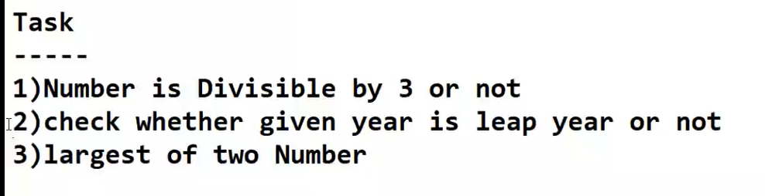

#Number is Divisible by 3 or not

Number = int(input("Enter the number: "))

if (Number%3==0):  
 print(Number,"is divisible by 3")  
else:  
 print(Number,"is not divisible by 3")

Enter the number: 9

9 is divisible by 3

#which is largest of two numbers  
  
num1 = int(input("Enter the number 1 :"))  
num2 = int(input("Enter the number 2 :"))  
  
if (num1 > num2):  
 print(num1,"is greatest")  
else:  
 print(num2,"is greatest")

Enter the number 1 :20

Enter the number 2 :6

20 is greatest

# given year is leep year or not  
  
year = int(input("enteŕ the year:"))  
  
if (year % 400 == 0 and year % 100 == 0):  
 print(year, "is leap year")  
  
elif (year % 4 == 0 and year % 100 != 0):  
 print(year, "is leap year")  
  
else:  
 print(year, "is not leap year")

enteŕ the year:2000

2000 is leap year